**АВТОСАЛОН**

**(Car Dealership)**

База данни за продажба на коли

Изготвена от

**Георги Иванов Иванов**

Специалност

**СИТ**

Факултетен номер

**20621545**

**Технически университет – Варна**

**Задание БД**

Да се проектира и реализира база от данни за АВТОСАЛОН, която да съхранява следната информация:

* Клиент – име, адрес, телефон;
* Служител на автосалона – име, позиция, телефон;
* Автомобил – марка, модел, година, цвят, километри, цена;
* Продажба – клиент, автомобил, служител, дата на продажба

Правила:

* Всеки клиент може да закупи повече от един автомобил
* Всеки автомобил може да бъде само от една марка/модел и да бъде закупен само от един клиент

Базата от данни трябва да е нормализирана и да позволява:

1. Въвеждане и корекции на данни.
2. Търсене на автомобили по марка, модел, цвят, година, километри, цена.
3. Справки за:

* Продадени автомобили от служител, подредени по дата на продажба;
* Последните 5 продажби подредени по цена;
* Закупени автомобили от клиент;
* Продажби за период.

**Модели**

**Логически моде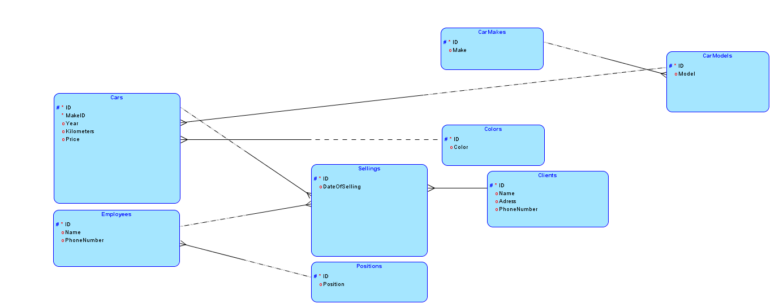л**

**Релационен модел**

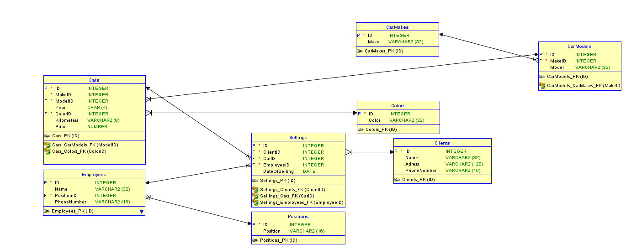

**Примерни данни**

**Car Makes**

**Car Models**

**Colors**

**Cars**

**Clients**

**Positions**

**Employees**

**Sellings**

**SQL команди – DDL ,DML**

**Създаване на таблици**

CREATE TABLE Cars

(

ID INTEGER NOT NULL,

ModelID INTEGER,

Year Char(4),

ColorID INTEGER,

Kilometers VARCHAR2(8),

Price NUMBER(8)

);

CREATE TABLE Employees

(

ID INTEGER NOT NULL,

Name VARCHAR2(32),

PositionID INTEGER,

PhoneNumber VARCHAR2(16)

);

CREATE TABLE Sellings

(

ID INTEGER NOT NULL,

ClientID INTEGER,

CarID INTEGER,

EmployeeID INTEGER,

DateOfSelling DATE

);

CREATE TABLE Positions

(

ID INTEGER NOT NULL,

Position VARCHAR2(16)

);

CREATE TABLE CarMakes

(

ID INTEGER NOT NULL,

Make VARCHAR2(32)

);

CREATE TABLE Colors

(

ID INTEGER NOT NULL,

Color VARCHAR2(32)

);

CREATE TABLE Clients

(

ID INTEGER NOT NULL,

Name VARCHAR2(32),

Adress VARCHAR2(128),

PhoneNumber VARCHAR2(16)

);

CREATE TABLE CarModels

(

ID INTEGER NOT NULL,

MakeID INTEGER,

Model VARCHAR2(32)

);

**Създаване на връзки между таблиците**

ALTER TABLE Cars ADD CONSTRAINT Cars_PK PRIMARY KEY(ID);

ALTER TABLE Employees ADD CONSTRAINT Employees_PK PRIMARY KEY(ID);

ALTER TABLE Sellings ADD CONSTRAINT Sellings_PK PRIMARY KEY(ID);

ALTER TABLE Positions ADD CONSTRAINT Positions_PK PRIMARY KEY(ID);

ALTER TABLE Colors ADD CONSTRAINT Colors_PK PRIMARY KEY(ID);

ALTER TABLE Clients ADD CONSTRAINT Clients_PK PRIMARY KEY(ID);

ALTER TABLE CarModels ADD CONSTRAINT CarModels_PK PRIMARY KEY(ID);

ALTER TABLE CarMakes ADD CONSTRAINT CarMakes_PK PRIMARY KEY(ID);

ALTER TABLE Cars ADD CONSTRAINT Cars_CarModels_FK FOREIGN KEY(ModelID)

REFERENCES CarModels(ID);

ALTER TABLE Cars ADD CONSTRAINT Cars_Colors_FK FOREIGN KEY(ColorID)

REFERENCES Colors(ID);

ALTER TABLE Sellings ADD CONSTRAINT Sellings_Clients_FK FOREIGN KEY(ClientID)

REFERENCES Clients(ID);

ALTER TABLE Sellings ADD CONSTRAINT Sellings_Cars_FK FOREIGN KEY(CarID)

REFERENCES Cars(ID);

ALTER TABLE Sellings ADD CONSTRAINT Sellings_Employees_FK FOREIGN KEY(EmployeeID)

REFERENCES Employees(ID);

ALTER TABLE CarModels ADD CONSTRAINT CarModels_CarMakes__FK FOREIGN KEY(MakeID)

REFERENCES CarMakes(ID);

**Добавяне на записи в таблиците**

INSERT INTO CarMakes(ID, Make)

VALUES(1, 'Audi');

INSERT INTO CarMakes(ID, Make)

VALUES(2, 'Mercedes');

INSERT INTO CarMakes(ID, Make)

VALUES(3, 'BMW');

INSERT INTO CarMakes(ID, Make)

VALUES(4, 'Volkswagen');

INSERT INTO CarMakes(ID, Make)

VALUES(5, 'Peugeot');

INSERT INTO CarMakes(ID, Make)

VALUES(6, 'Renault');

INSERT INTO CarMakes(ID, Make)

VALUES(7, 'Porsche');

INSERT INTO CarModels(ID, MakeID, Model)

VALUES(1, 1, 'A5');

INSERT INTO CarModels(ID, MakeID, Model)

VALUES(2, 1, 'Q7');

INSERT INTO CarModels(ID, MakeID, Model)

VALUES(3, 4, 'Golf 5');

INSERT INTO CarModels(ID, MakeID, Model)

VALUES(4, 7, 'Cayenne');

INSERT INTO CarModels(ID, MakeID, Model)

VALUES(5, 3, 'X5');

INSERT INTO CarModels(ID, MakeID, Model)

VALUES(6, 2, 'S class');

INSERT INTO CarModels(ID, MakeID, Model)

VALUES(7, 2, 'C class');

INSERT INTO Colors(ID, Color)

VALUES(1, 'black');

INSERT INTO Colors(ID, Color)

VALUES(2, 'white');

INSERT INTO Colors(ID, Color)

VALUES(3, 'silver');

INSERT INTO Colors(ID, Color)

VALUES(4, 'red');

INSERT INTO Colors(ID, Color)

VALUES(5, 'brown');

INSERT INTO Positions(ID, Position)

VALUES(1, 'Seller');

INSERT INTO Positions(ID, Position)

VALUES(2, 'Manager');

INSERT INTO Clients(ID, Name, Adress, PhoneNumber)

VALUES(1, 'Kevin', 'Varna, ul. Prilep, 12', '0885163248');

INSERT INTO Clients(ID, Name, Adress, PhoneNumber)

VALUES(2, 'Peter', 'Sofia, kv. Boyana, bl. 34', '0889122254');

INSERT INTO Clients(ID, Name, Adress, PhoneNumber)

VALUES(3, 'Galena', 'Varna, kv. Troshevo, bl. 24', '0895772321');

INSERT INTO Clients(ID, Name, Adress, PhoneNumber)

VALUES(4, 'Simeon', 'Burgas, ul. Kiril i Metodii, 22', '0887142290');

INSERT INTO Clients(ID, Name, Adress, PhoneNumber)

VALUES(5, 'Ivana', 'Ruse, ul. Dunav, 34', '0876435230');

INSERT INTO Clients(ID, Name, Adress, PhoneNumber)

VALUES(6, 'Leo', 'Plovdiv, ul. Radomir, 14', '0876490120');

INSERT INTO Employees(ID, Name, PositionID, PhoneNumber)

VALUES(1, 'Georgi', 2, '0889214533');

INSERT INTO Employees(ID, Name, PositionID, PhoneNumber)

VALUES(2, 'Deqn', 1, '0887323344');

INSERT INTO Employees(ID, Name, PositionID, PhoneNumber)

VALUES(3, 'Ognqn', 1, '0885674322');

INSERT INTO Employees(ID, Name, PositionID, PhoneNumber)

VALUES(4, 'Hristo', 1, '0889771232');

INSERT INTO Employees(ID, Name, PositionID, PhoneNumber)

VALUES(5, 'Pavel', 2, '0882711538');

INSERT INTO Employees(ID, Name, PositionID, PhoneNumber)

VALUES(6, 'Jivko', 1, '0883992134');

INSERT INTO Cars(ID, ModelID, Year, ColorID, Kilometers, Price)

VALUES(1, 2, '2005', 3, '144000', 14500);

INSERT INTO Cars(ID, ModelID, Year, ColorID, Kilometers, Price)

VALUES(2, 1, '2010', 1, '196500', 12000);

INSERT INTO Cars(ID, ModelID, Year, ColorID, Kilometers, Price)

VALUES(3, 4, '2012', 2, '290000', 26000);

INSERT INTO Cars(ID, ModelID, Year, ColorID, Kilometers, Price)

VALUES(4, 3, '2005', 1, '130000', 22000);

INSERT INTO Cars(ID, ModelID, Year, ColorID, Kilometers, Price)

VALUES(5, 5, '2009', 3, '142500', 17000);

INSERT INTO Cars(ID, ModelID, Year, ColorID, Kilometers, Price)

VALUES(6, 5, '2006', 2, '188500', 14000);

INSERT INTO Cars(ID, ModelID, Year, ColorID, Kilometers, Price)

VALUES(7, 2, '2019', 1, '200500', 70000);

INSERT INTO Cars(ID, ModelID, Year, ColorID, Kilometers, Price)

VALUES(8, 1, '2000', 1, '388500', 4000);

INSERT INTO Cars(ID, ModelID, Year, ColorID, Kilometers, Price)

VALUES(9, 3, '2007', 2, '288500', 24000);

INSERT INTO Cars(ID, ModelID, Year, ColorID, Kilometers, Price)

VALUES(10, 4, '2011', 3, '118000', 22000);

INSERT INTO Cars(ID, ModelID, Year, ColorID, Kilometers, Price)

VALUES(11, 5, '2001', 1, '122000', 12000);

INSERT INTO Sellings(ID, ClientID, CarID, EmployeeID, DateOfSelling)

VALUES(1, 2, 4, 3, TO_DATE('2021-04-12', 'YYYY-MM-DD'));

INSERT INTO Sellings(ID, ClientID, CarID, EmployeeID, DateOfSelling)

VALUES(2, 1, 2, 1, TO_DATE('2021-01-12', 'YYYY-MM-DD'));

INSERT INTO Sellings(ID, ClientID, CarID, EmployeeID, DateOfSelling)

VALUES(3, 3, 5, 1, TO_DATE('2021-11-23', 'YYYY-MM-DD'));

INSERT INTO Sellings(ID, ClientID, CarID, EmployeeID, DateOfSelling)

VALUES(4, 4, 2, 2, TO_DATE('2021-07-14', 'YYYY-MM-DD'));

INSERT INTO Sellings(ID, ClientID, CarID, EmployeeID, DateOfSelling)

VALUES(5, 1, 7, 1, TO_DATE('2021-12-01', 'YYYY-MM-DD'));

INSERT INTO Sellings(ID, ClientID, CarID, EmployeeID, DateOfSelling)

VALUES(6, 3, 9, 3, TO_DATE('2020-04-02', 'YYYY-MM-DD'));

INSERT INTO Sellings(ID, ClientID, CarID, EmployeeID, DateOfSelling)

VALUES(7, 1, 8, 1, TO_DATE('2021-12-11', 'YYYY-MM-DD'));

INSERT INTO Sellings(ID, ClientID, CarID, EmployeeID, DateOfSelling)

VALUES(8, 2, 10, 1, TO_DATE('2020-10-03', 'YYYY-MM-DD'));

INSERT INTO Sellings(ID, ClientID, CarID, EmployeeID, DateOfSelling)

VALUES(9, 3, 7, 2, TO_DATE('2021-04-24', 'YYYY-MM-DD'));

INSERT INTO Sellings(ID, ClientID, CarID, EmployeeID, DateOfSelling)

VALUES(10, 4, 4, 4, TO_DATE('2020-04-07', 'YYYY-MM-DD'));

INSERT INTO Sellings(ID, ClientID, CarID, EmployeeID, DateOfSelling)

VALUES(11, 4, 1, 2, TO_DATE('2021-05-17', 'YYYY-MM-DD'));

INSERT INTO Sellings(ID, ClientID, CarID, EmployeeID, DateOfSelling)

VALUES(12, 1, 7, 6, TO_DATE('2021-06-27', 'YYYY-MM-DD'));

**Редактиране на записи от таблиците**

UPDATE Cars

SET Cars.Price = 10000

WHERE Cars.Year = '2005';

UPDATE CarMakes

SET CarMakes.Make = 'Citroen'

WHERE CarMakes.ID = 6;

UPDATE CarModels

SET CarModels.Model = 'Panamera'

WHERE CarModels.ID = 4;

UPDATE Positions

SET Positions.Position = 'General Manager'

WHERE Positions.ID = 2;

UPDATE Clients

SET Clients.Name = 'Ivelina',

Clients.Adress = 'kv. Krasna Polqna, 47',

Clients.PhoneNumber = '0889722147'

WHERE Clients.ID = 3;

UPDATE Sellings

SET Sellings.CarID = 2,

Sellings.ClientID = 3,

Sellings.EmployeeID = 3,

Sellings.DateOfSelling = TO_DATE('2021-09-14', 'YYYY-MM-DD')

WHERE Sellings.ID = 4;

**Изтриване на записи от таблиците**

DELETE FROM Colors

WHERE Colors.ID = 5;

DELETE FROM Cars

WHERE Cars.ID = 11;

DELETE FROM Sellings

WHERE Sellings.ID = 11;

DELETE FROM Employees

WHERE Employees.Name = 'Pavel';

DELETE FROM Clients

WHERE Clients.Name = 'Leo';

**Търсения и справки**

**Търсене на автомобил по марка**

SELECT

Cars.ID,

CarMakes.Make,

CarModels.Model,

Cars.Year,

Colors.Color,

Cars.Kilometers,

Cars.Price

FROM Cars

JOIN CarModels ON CarModels.ID = Cars.ModelID

JOIN CarMakes ON CarMakes.ID = CarModels.MakeID

JOIN Colors ON Colors.ID = Cars.ColorID

WHERE CarMakes.Make = 'Audi'

ORDER BY Cars.ID;

**Търсене на автомобил по модел**

SELECT

Cars.ID,

CarMakes.Make,

CarModels.Model,

Cars.Year,

Colors.Color,

Cars.Kilometers,

Cars.Price

FROM Cars

JOIN CarModels ON CarModels.ID = Cars.ModelID

JOIN CarMakes ON CarMakes.ID = CarModels.MakeID

JOIN Colors ON Colors.ID = Cars.ColorID

WHERE CarModels.Model = 'A5'

ORDER BY Cars.ID;

**Търсене на автомобил по година**

SELECT

Cars.ID,

CarMakes.Make,

CarModels.Model,

Cars.Year,

Colors.Color,

Cars.Kilometers,

Cars.Price

FROM Cars

JOIN CarModels ON CarModels.ID = Cars.ModelID

JOIN CarMakes ON CarMakes.ID = CarModels.MakeID

JOIN Colors ON Colors.ID = Cars.ColorID

WHERE Cars.Year = '2005'

ORDER BY Cars.ID;

**Търсене на автомобил по километри**

SELECT

Cars.ID,

CarMakes.Make,

CarModels.Model,

Cars.Year,

Colors.Color,

Cars.Kilometers,

Cars.Price

FROM Cars

JOIN CarModels ON CarModels.ID = Cars.ModelID

JOIN CarMakes ON CarMakes.ID = CarModels.MakeID

JOIN Colors ON Colors.ID = Cars.ColorID

WHERE Cars.Kilometers <= '150000'

ORDER BY Cars.ID;

**Търсене на автомобил по ценови диапазон**

SELECT

Cars.ID,

CarMakes.Make,

CarModels.Model,

Cars.Year,

Colors.Color,

Cars.Kilometers,

Cars.Price

FROM Cars

JOIN CarModels ON CarModels.ID = Cars.ModelID

JOIN CarMakes ON CarMakes.ID = CarModels.MakeID

JOIN Colors ON Colors.ID = Cars.ColorID

WHERE Cars.Price >= 5000 AND Cars.Price <= 15000

ORDER BY Cars.ID;

**Справка продадени автомобили от служител, подредени по дата на продажба**

SELECT

Sellings.ID,

Sellings.ClientID,

Sellings.CarID,

Sellings.EmployeeID,

Employees.Name,

Positions.Position,

Employees.PhoneNumber,

Sellings.DateOfSelling

FROM Sellings

JOIN Employees ON Employees.ID = Sellings.EmployeeID

JOIN Positions ON Positions.ID = Employees.PositionID

WHERE Employees.Name = 'Georgi'

ORDER BY Sellings.DateOfSelling;

**Справка последни 5 продажби**

SELECT *

FROM (

SELECT

Sellings.ID Id,

Sellings.ClientID Client_ID,

Clients.Name Client_Name,

Sellings.CarID Car_ID,

CarMakes.Make Car_Make,

CarModels.Model Car_Model,

Sellings.EmployeeID Employee_ID,

Employees.Name Employee_Name,

Cars.Price Car_Price,

Sellings.DateOfSelling Date_Of_Selling

FROM Sellings

JOIN Cars ON Cars.ID = Sellings.CarID

JOIN CarModels ON CarModels.ID = Cars.ModelID

JOIN CarMakes ON CarMakes.ID = CarModels.MakeID

JOIN Clients ON Clients.ID = Sellings.ClientID

JOIN Employees ON Employees.ID = Sellings.EmployeeID

ORDER BY Sellings.DateOfSelling DESC

)

WHERE ROWNUM <= 5;

**Справка за закупени автомобили от клиент**

SELECT

Sellings.ID,

Sellings.ClientID,

Clients.Name,

Clients.Adress,

Clients.PhoneNumber,

Sellings.CarID,

Sellings.EmployeeID,

Cars.Price,

Sellings.DateOfSelling

FROM Sellings

JOIN Clients ON Clients.ID = Sellings.ClientID

JOIN Cars ON Cars.ID = Sellings.CarID

WHERE Clients.Name = 'Peter'

ORDER BY Sellings.ID;

**Справка за продадени автомобили за последните три месеца**

SELECT

Sellings.ID,

Sellings.ClientID,

Sellings.CarID,

CarMakes.Make,

CarModels.Model,

Sellings.EmployeeID,

Employees.Name,

Cars.Price,

Sellings.DateOfSelling

FROM Sellings

JOIN Cars ON Cars.ID = Sellings.CarID

JOIN CarModels ON CarModels.ID = Cars.ModelID

JOIN CarMakes ON CarMakes.ID = CarModels.MakeID

JOIN Employees ON Employees.ID = Sellings.EmployeeID

WHERE Sellings.DateOfSelling > '2021-10-01';

